**Restaurant Management System**

Our project is based on restaurant management system wherein we have used database to store values supported by interactive GUI setup.

Installing Softwares:-

1. Kindly install MySQL and Netbeans IDE(Installer of which are provided in softwares folder in the zip file).
2. In MySQL kindly use userid:- root and Password as admin.
3. You need to add jCalender and jDateChooer in Netbeans.
4. Copy the content of mysql.txt file(provided in zip file) and paste it in MySQL after logging in.
5. Open netbeans ide and add the project file named optimist in the ide by clicking on the open project button in menu bar.
6. Now click on the run project button to run the project.

Navigating the Project:-

1. Navigate to aMainPage in the project and press the run button.



1. Click on any part of the window to further navigate to login window.
2. The login window is divided into 2 parts:Branch Login and Owner Login as shown.

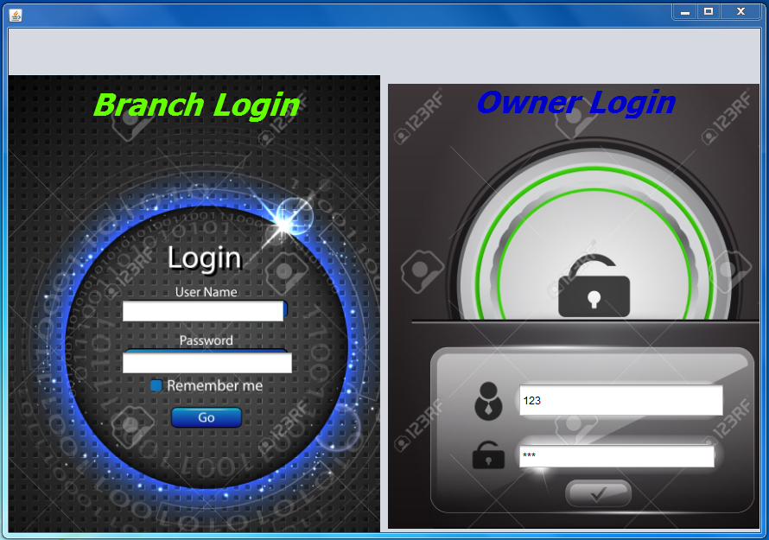

1. Enter 123 as username and password in any of the window to further navigate to appropriate page.
2. Logging in Owner login will take you to a window where you can add,modify,delete food item and to manage employees.

A small example of adding Manchurian in shown below.

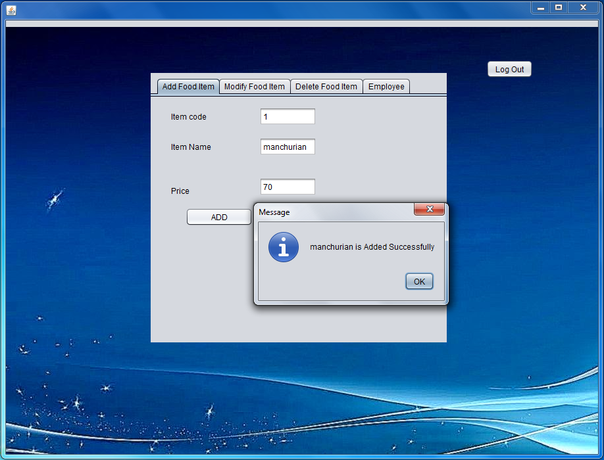

Example below shows how to modify an food item

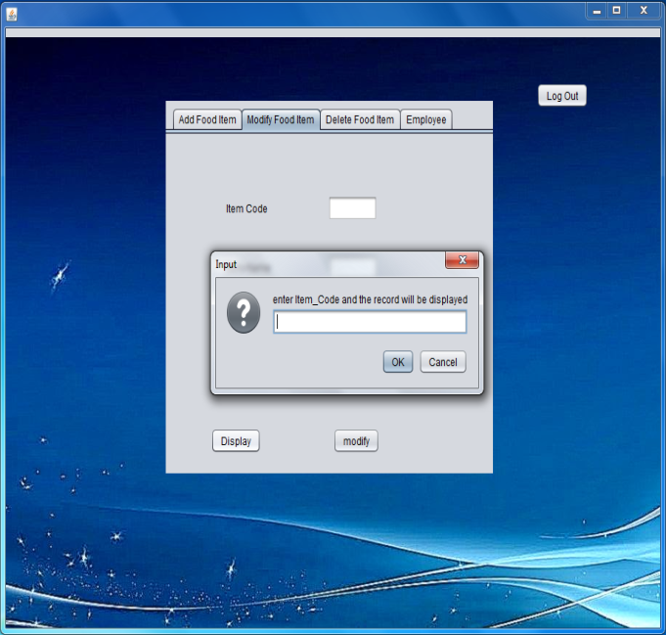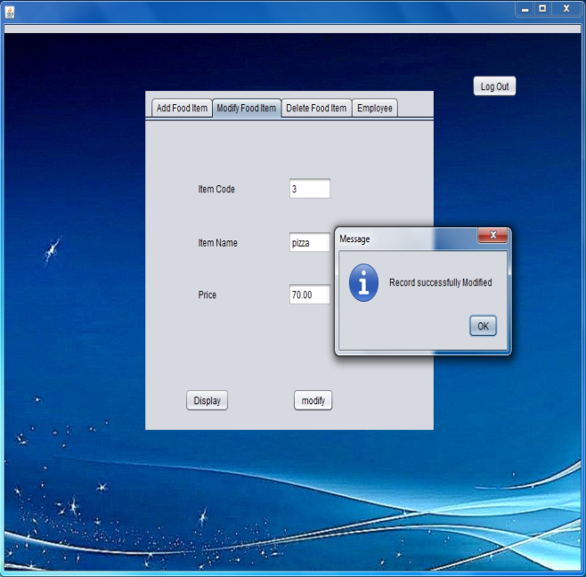

Example below shows how to delete food item.

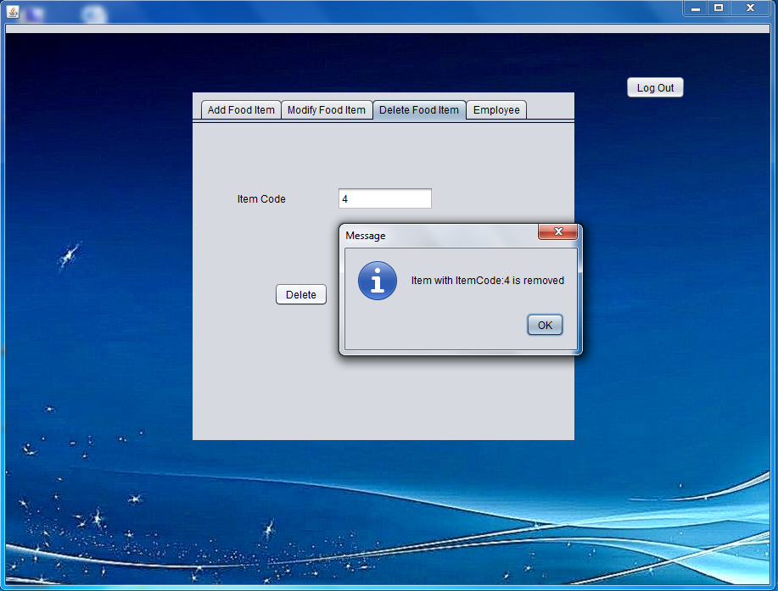

Example below shows how to manage employees by using our interface.

For adding an employee.

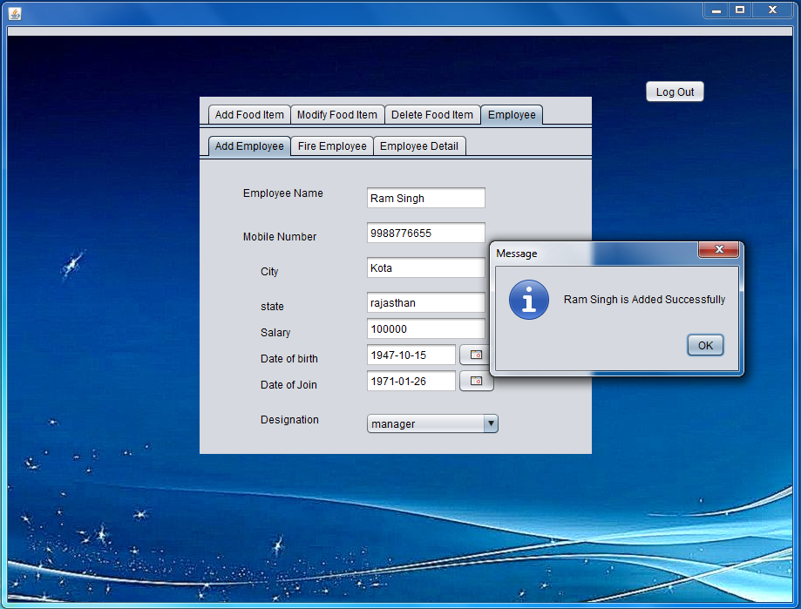

To fire/remove an employee.

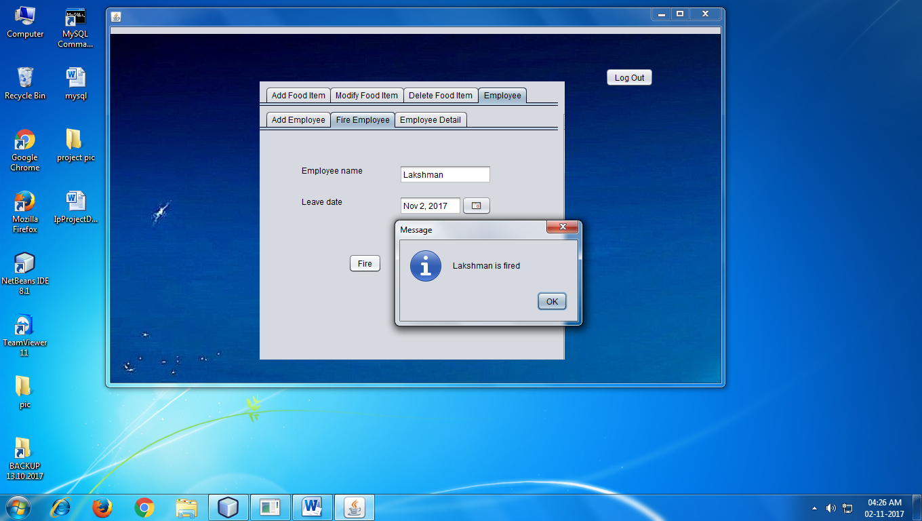

To Modify Employee details.

First click on display to get details of the employee.

Then do the changes and press modify.

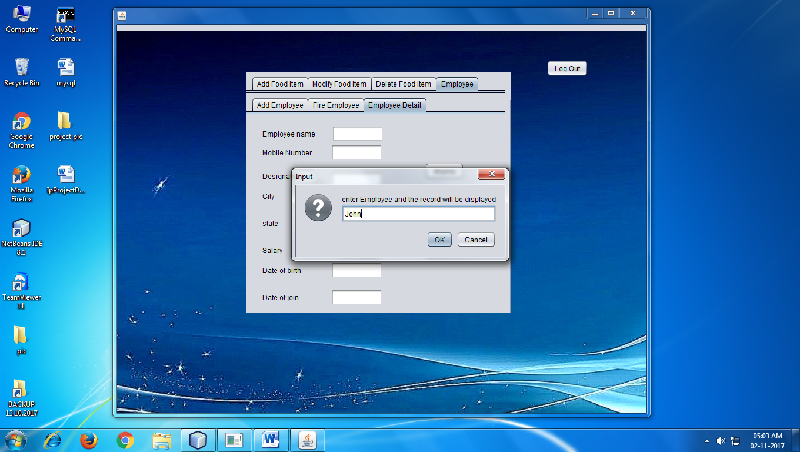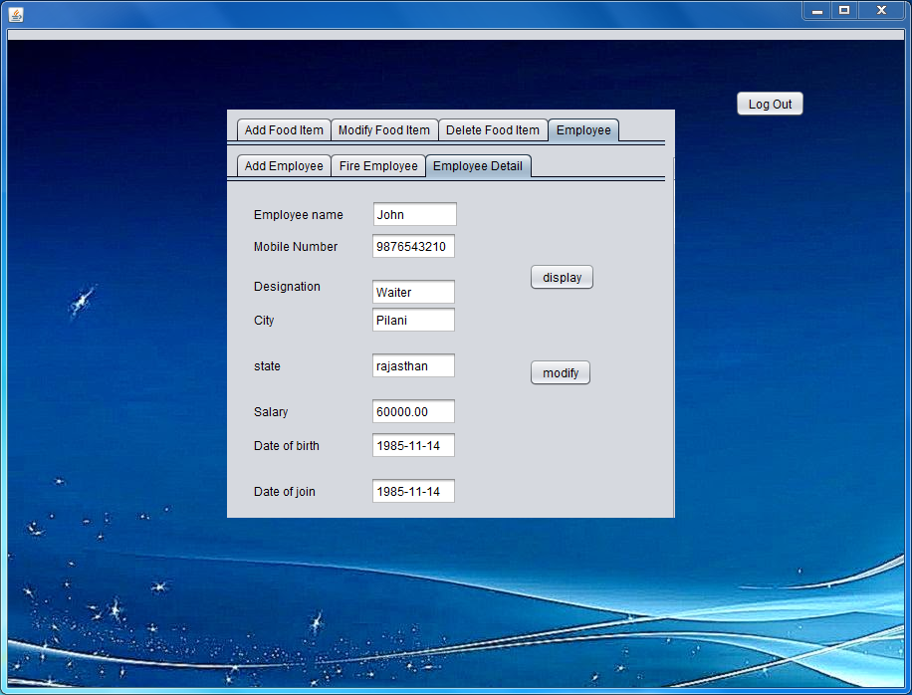

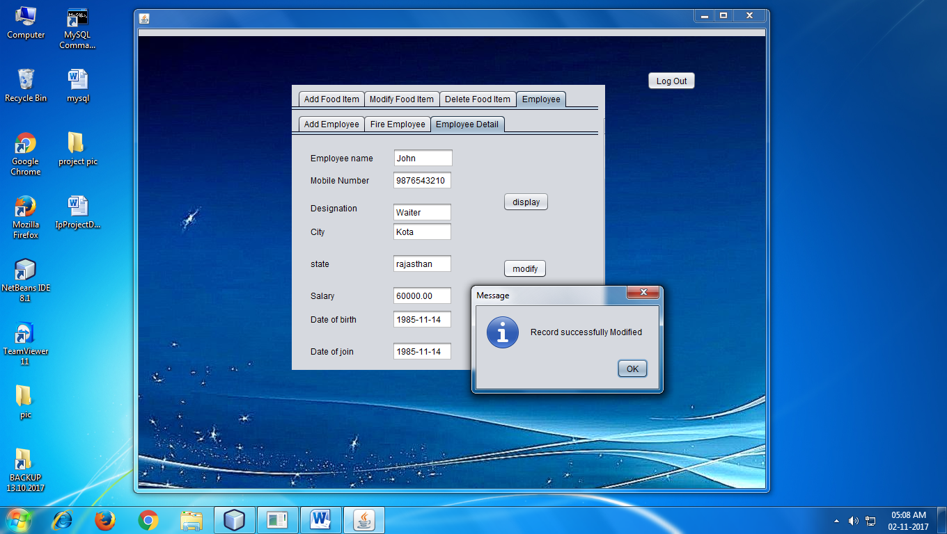

1. Like wise each actions performed would be reflected in database accordingly in appropriate table.
2. Logging in Branch page will take you further to a page shown below.

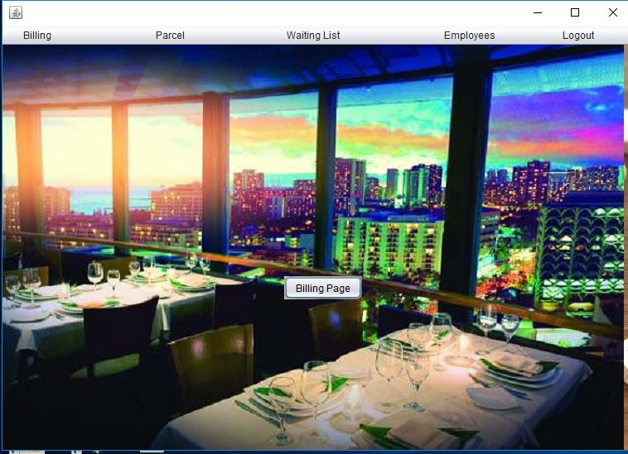

1. Upon clicking on any of the options in menu bar the background color of the frame will change and a button will appear.

Clicking on billing button in menu bar.

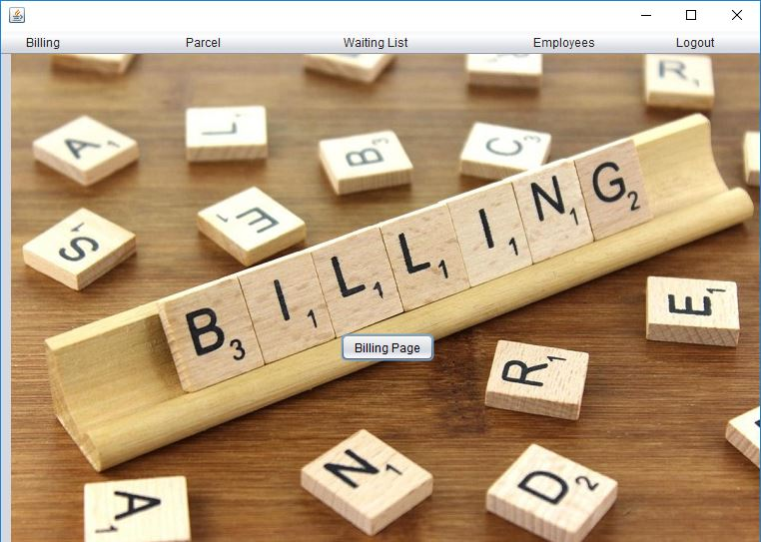

Clicking on Parcel button in menu bar.

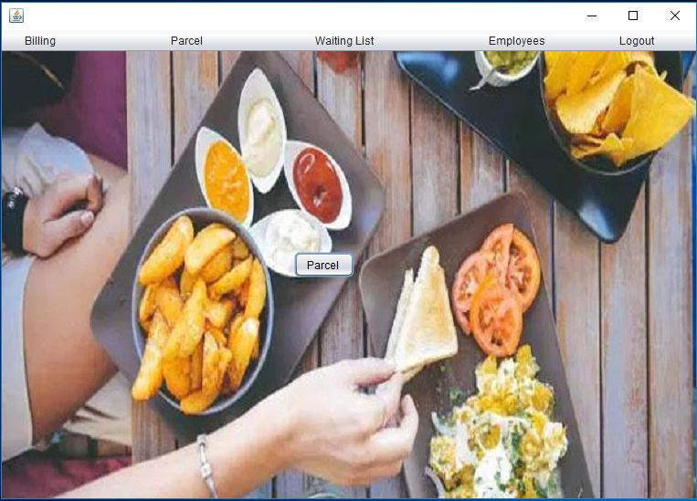

Clicking on Waiting list button in menu bar.

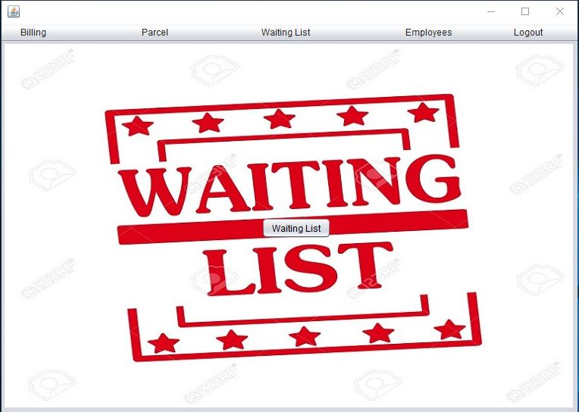

Clicking on Employee button in menu bar.



1. On clicking the button you would be directed to appropriate page which would allow you to do perform the intended action.

On clicking on billing page:

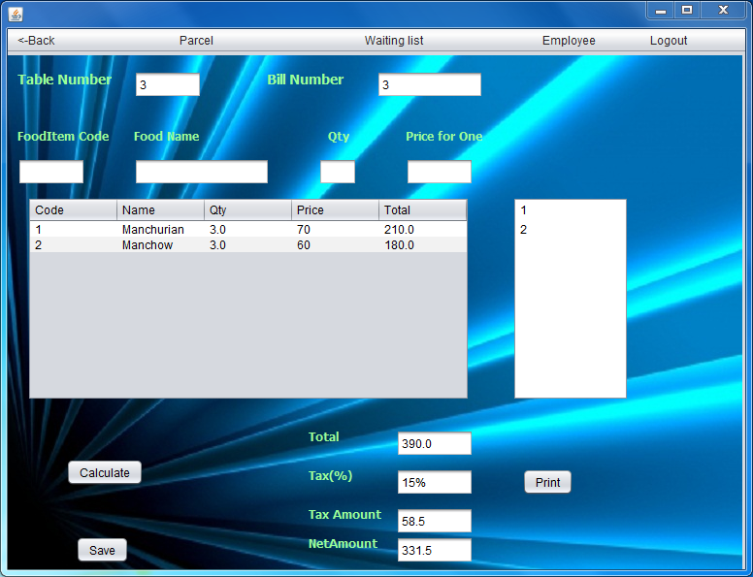

Each entry in identified by the table number.

To enter food item for a table enter item code and press enter and then enter quantity and press enter.

Press calculate to calculate the bill amount

Press save to save the details in database.

Also tables occupied are shown in the list(right side of the page).

Parcel Page:

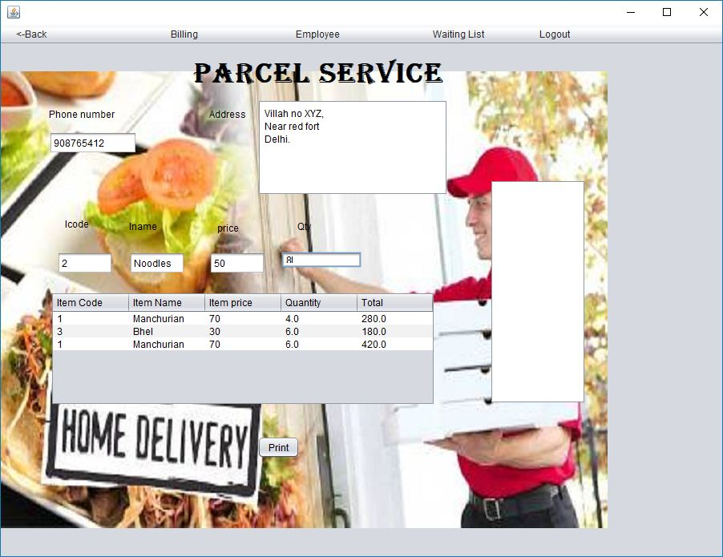

Similar thing goes for parcel where in each entry in identified by mobile number.

Waiting list:-

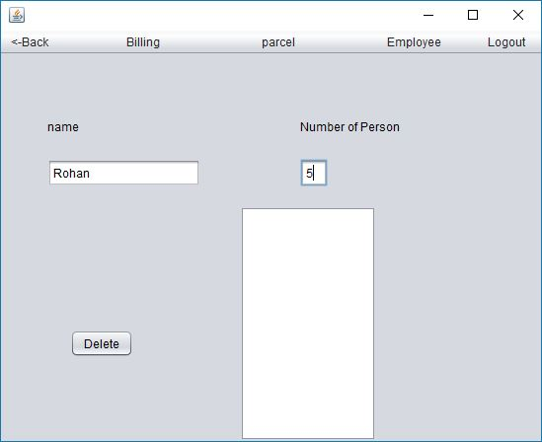 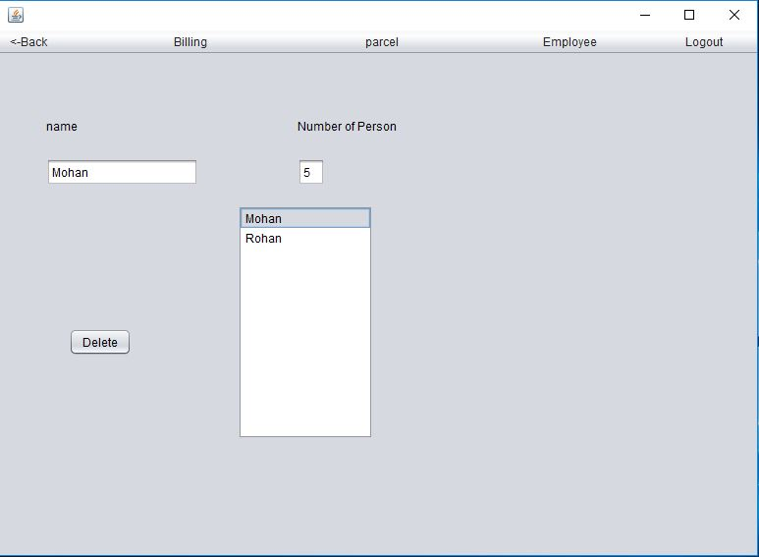

We can enter name and no.of person and add them in list by pressing enter.

When there chance comes we can delete them from the list by clicking on there name and pressing the delet button.

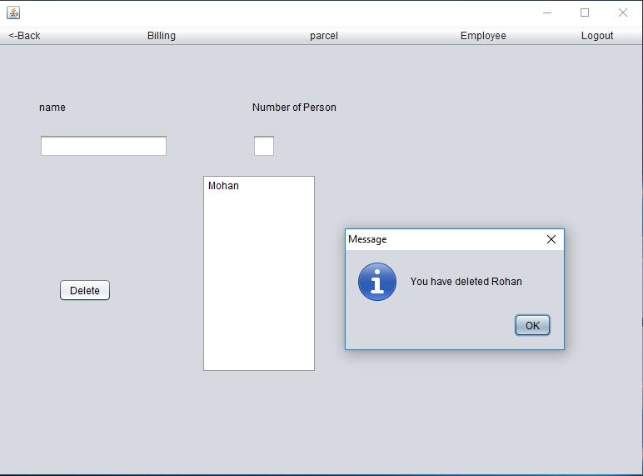

Employee Page:-

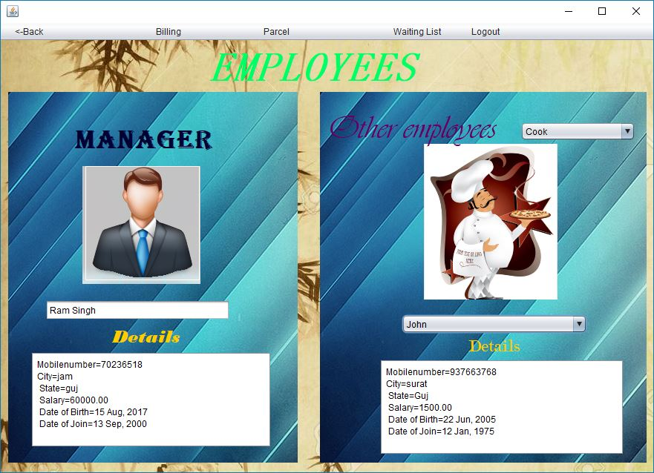

The manager of the branch is shown in one window and other employees are shown in another window.

To see other employee details first chose there designation(cook in this eg)) and then chose the name(john in this example).